# Memorize these points

## Some important calculation of runtime/space complexity

### Recursive Runtimes and Space Complexities

int f(int n) {

if(n<=0) return 1;

return f(n-1)+f(n-1);

}

How many recursive calls?

**Runtime complexity of Recursive methods = O(branches ^ depth)**

At each step, we are calling recursion twice and number reduces by 1. So, total number of recursions is 2^n. So, **Runtime Complexiy = O(2^N) that is same as number of branches in the tree.**

f(4)

f (3) f(3)

f(2) f(2) f(2) f(2)

f(1) f(1) f(1) f(1) f(1) f(1) f(1) f(1)

f(0) f(0) f(0) f(0) f(0) f(0) f(0) f(0) f(0) f(0) f(0) f(0) f(0) f(0) f(0) f(0)

Height of tree is 4. Number of stack slots will be used is 4 = **O(n) is the space complexity that is same as height of the tree**.

Let’s take an example of Binary Search

BinarySearch(8)

BinarySearch (4) BinarySearch (4)

(not used)

BinarySearch (2) BinarySearch (2)

(not used)

BinarySearch (1) BinarySearch (1)

(not used)

At each level only 1 branch is used for comparison. So, number of branches is approx log 8. So, runtime complexity is log 8.

Heght of the tree is log 8. So, space complexity is log 8.

### When number of comparisons at each step doubles

1+2+4+8+16+……X

Runtime complexity = 2^n+1 -1 = O(2^n)

The sum of the sequence of powers of two is roughly equal o the next value in the sequence.

2^0 +2^1 +2^2 +2^3+2^4 = 2^5 - 1

### When number of comparisons at each step halvs

Let’s take Binary Search algorithm

At every step, number of elements available to compare halvs

N=16

N=8

N=4

N=2

N=1

N = 2^k

Log2 N = k

e.g.

16 = 2^4

log2 16 = 4

This is a bit hard to understand. Understand the explanation given in Binary Search section.

Basically, when number of comparisons halvs at each step, then time complexity is O(log n).

### When number of comparisions increases by 1 at each step

(pg 46, 47 of CCA book)

for(int i=0; i<n; i++) {

for(int j=0; i<n; i++) {

…

}

}

Number of operations – n + n-1+ n-2 + n-3 +…..+ 1

So it is 1 + 2 + 3 + 4 + ….. n

It will come to n(n+1)/2, which will be O(n^2). This is how you calculate the total

<https://www.wikihow.com/Sum-the-Integers-from-1-to-N>

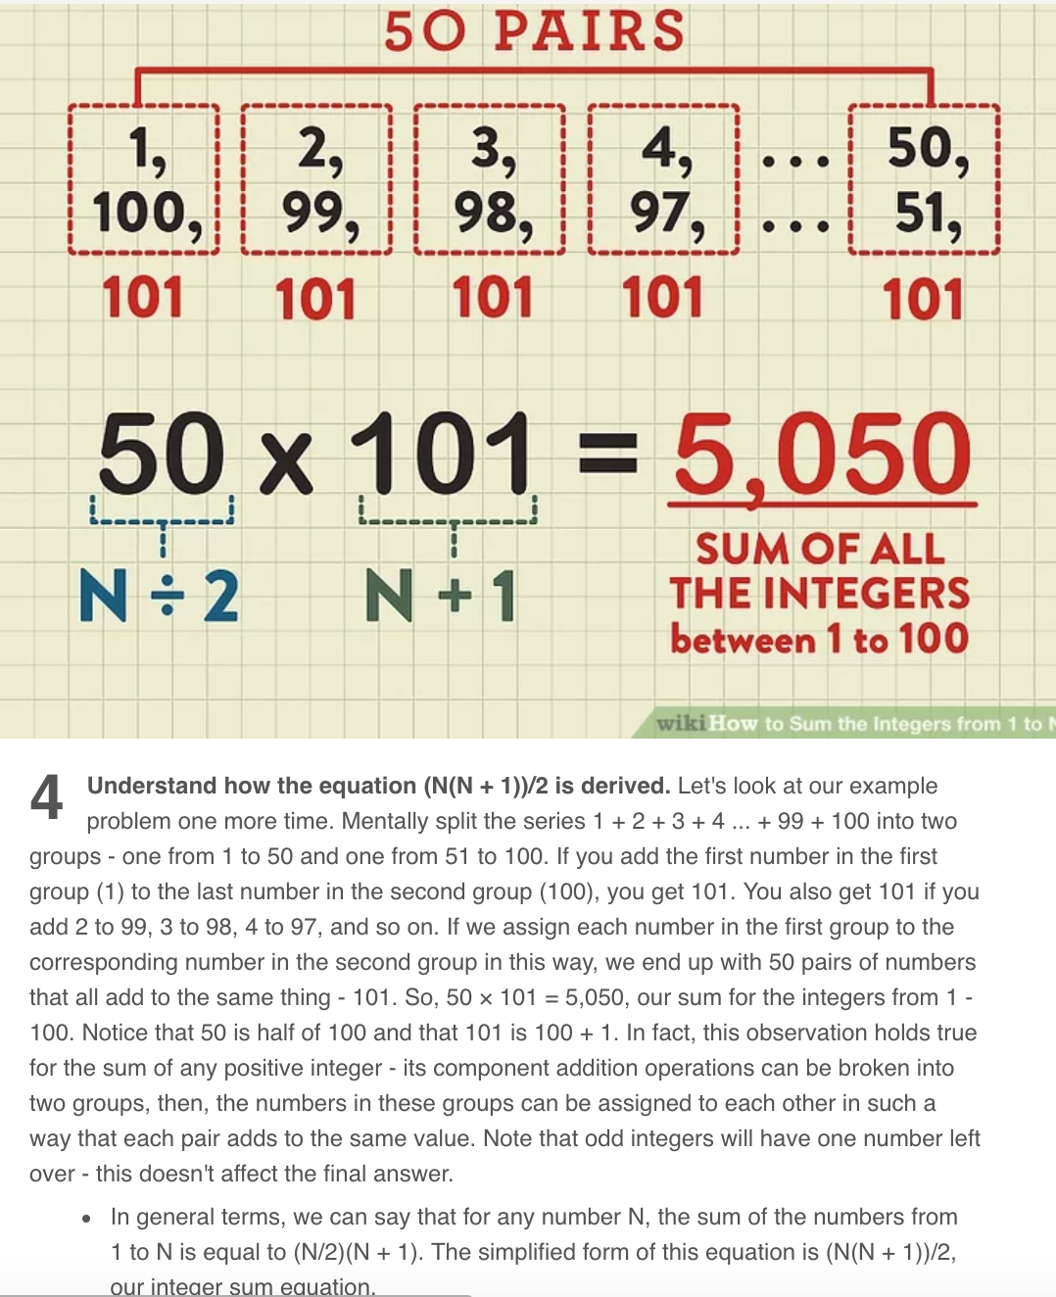

Similarly,

for(int i=0; i<n; i++) {

for(int j=i+1; i<n; i++) {

…

}

}

number of comparisons n-1 + n-2 + n-3 +…… 1

so, it is 1 + 2 + 3 + 4 + ….. n-1

In above fomula (n(n+1)/2), replace n by n-1

So, it will be (n-1)n/2, which will be O(n^2)

### How long it takes to Sort Strings (not integers)?

(pg 49 of CCA book)

To sort an array of integers, quick sort takes O(n log n), we know that. During quick sort, when comparison of 2 integers happens, it takes O(1). Look at Integer class’ compareTo method.

But in case of Strings, to compare two strings of size s takes O(s). So, sorting of strings will take O(sn log n).

## Tricking question

for(int x=2; x*x <= n; x++) {

….

}

What is runtime complexity?

x*x <= n

x^2 <= n

x <= sqrt(n)

So, runtime complexity= O(sqrt(n))

### Momizaiton example

Pg 53 of CCA book

Fibonacci example with memoization

## O(n!) example

Pg 51 of CCA book

## How to work with array?

binarySearchRecursive(array, 0, array.**length** - 1, elementToSearch)

* Always pass start and end element position in array to recursive method.
* One of the Exit condition will be if(start<end)…
* When you need to convert recursive method into iterative method, extra passed parameters to recursive method becomes local variables and after that that you need to add a while loop for reoccurring code.

## How to find mid of array?

binarySearchRecursive(array, 0, array.**length** - 1, elementToSearch)

void binarySearchRecursive(int[] array, int start, int end) {

…

mid = (end+start)/2

…

}

## How to choose Random number from array?

quickSort (A, 0, A.length – 1);

void quickSort(**int**[] A, **int** start, **int** end) {

…

**int** pivot = **new** Random().nextInt((end - start) + 1) + start;

or

**int** pivot = **new** Random().nextInt(A.length - start) + start;

…

}

## How to do shuffling?

void shuffle(int[] A) {

// if you start from i=0, new Random(0,0) will error out

for(int i=1; i < A.length;i++) {

// pick random number between 0 and i

// People sometimes choose random number between 0 and n-1, but it doesn't give uniformly random result

int randomIndex = new Random().nextInt(0, i);

exchange(A, i, randomIndex);

}

}

## How to write an in-place algorithm?

Think of the difference between Quick Sort using Aux arrays and in-place.

Just like Merge Sort, Quick Sort is also Divide and Concur algorithm.

Just like Merge Sort, you can create aux arrays in Quick Sort also, but better approach is to do quick sort in-place.

This teaches us a trick:

whenever you need to do something in-place, think of using an additional pointer. One pointer is for normal traversal of an array and another pointer increments on some special condition. Hard thing is to find this special condition.

## What makes the running time n! instead of n^2?

For(int i=0; i<n; i++) {

For(int j=0; j<n; j++) {

….

}

}

This is n^2 operations.

Let’s say, n=10 (0 to 9). You have 10 dots in a graph. Starting from 0, you need to find all combinations to reach to 9. There can be many combinations. 0->1->2…->9, 0->2->1->…9 etc.

This kind of behavior needs n! operations.

Greedy Algorithm or Dynamic Programming is a solution for n! problem. Greedy Algorithm gives close to optimal solution at the end and Dynamic Programming give most optimal solution at the end, but you cannot Dynamic Programming all the time. For Dynamic Programming is for Knacksap Problem. In Knacksap problem, you need to be told the max weight that Knacksap can hold and every item that you can put in knacksap has to have concrete weight. You cannot say whatever weight is available, I will put it in knacksap.

## How many ways to create a graph?

1. Hash Table

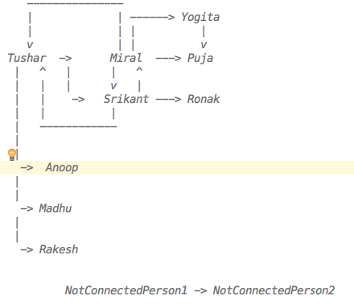

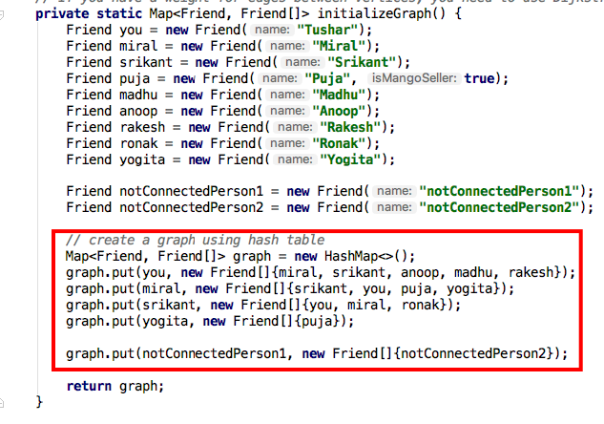

1. Matrix

|  |  |  |  |  |  |  |  |  |  |  |  |
| --- | --- | --- | --- | --- | --- | --- | --- | --- | --- | --- | --- |
|  | Tushar | Miral | Srikant | Anoop | Madhu | Rakesh | Yogita | Puja | Ronak | NotConnectedPerson1 | NotConnectedPerson2 |
| Tushar | 1 | 1 | 1 | 1 | 1 | 1 |  |  |  |  |  |
| Miral | 1 | 1 | 1 |  |  |  | 1 | 1 |  |  |  |
| Srikant | 1 | 1 | 1 |  |  |  |  |  | 1 |  |  |
| Anoop |  |  |  |  |  |  |  |  |  |  |  |
| Madhu |  |  |  |  |  |  |  |  |  |  |  |
| Rakesh |  |  |  |  |  |  |  |  |  |  |  |
| Yogita |  |  |  |  |  |  |  | 1 |  |  |  |
| Puja |  |  |  |  |  |  |  |  | 1 |  |  |
| Ronak |  |  |  |  |  |  |  |  |  |  |  |
| NotConnectedPerson1 |  |  |  |  |  |  |  |  |  |  | 1 |
| NotConnectedPerson2 |  |  |  |  |  |  |  |  |  |  |  |

Matrix is created using 2-D array

A[0][0] = [Tushar][Tushar]

A[0][1] = [Tushar][Miral]

and so on

## When to use Linear Programming?

<https://www.youtube.com/watch?v=M4K6HYLHREQ>

Under some constraint, you need to maximize something (e.g. profit) As mentioned in above youtube video, constraint is number of available hours for farming. In that constraint, you need to maximize the profit by putting some corns and some oats plants giving different amount of profits.

## When to use Binary Search Tree instead of Binary Search?

Binary Search needs sorted array. Whenever a new element needs to be added in an array, array needs to be sorted. This is not good.

BST works BEST on unordered array with O(log n). It works worse on ordered array with O(n) search time.

BST is a symmetric tree. Means left nodes of any nodes are always lesser and right nodes are always bigger.

BST takes O(log n) for insert/delete. It takes avg O(log n) and worse O(n) for search. Worst case is when BST is created from sorted array. BST will have all elements on one side of the tree only. That's why height of the tree will be n because it won't be balanced.

Unbalanced Tree:

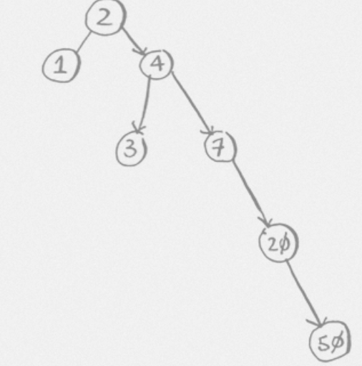

Comparing BST to Binary Search:

For Binary Search, you need sorted array, so Inserting and deleting in array to keep it sorted may take O(n). Search takes same as Binary Search.

So BST has an advantage over Binary Search for insert/delete/search when array is unordered.

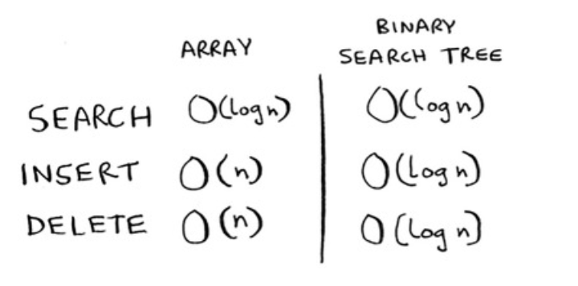

**Which algorithm is used to create perfectly balanced tree?**

Red-Black Tree

### Which algorithm is used by Databases?

B-Tree

### Which algorithm is used for finding min or max?

Min-Heap, Max-Heap (prioritiy queue)

Priority Queue uses Heap Sort.

Heap Sort is very useful when you need to find min/max in O(1) time and insert an element in O(log n) time. It requires an aux array through. so O(n) space and total execution time is O(nlogn).

Priority Queue is based on Binary Heap (BinaryHeap.java in algorithms package).  
There is Min BinaryHeap and Max BinaryHeap.  
BinaryHeap look like a tree, but it is just a reordering of elements in an array. Based on index you can find higher priority the element.  
You can find min priority element on the top of Min BinaryHeap, you don't need to search for it like BST.

### When you encounter a problem that has inputs from multiple arrays (multiple sources), what should you think of?

Using Priority Queue to store inputs coming from multiple sources. Priority Queue.

### Arrays.sort, Collections.sort

* Arrays.sort uses 3-Way-QuickSort for int[], float[] etc. But it uses Merge Sort/Insertion Sort for Object[].

If positions for primitives are changed during sorting, then it's ok, but it's not ok for Objects.

* Collections.sort uses Arrays.sort internally.
* Heap Sort uses Binary Heap algorithm and Priority Queue uses Heap Sort.

Remember, Quick Sort is a in-place sorting algorithm but it is unstable.

From BSIS and M-HQ sorts, HQ are unstable.

### String Operations

For any String operation, remember below points

* String contains char[] and you can use char[] chars = str.toCharArray()  
  - str.charAt(i) is very useful
* Ask interviewer whether you should support ascii/extended ascii/unicode chars.  
   ASCII chars are english numbers+letters+special chars = 128. Extended ascii chars (total 256) contains many other special chars.  
   If interviewer say ascii is good, then use aux array of size 128 (char[] chars = new char[128])
* Default value of char[] is Character.MIN_VALUE ('\u0000')
* Remember this pattern  
    
   char[] chars = new char[128]

for (int i = 0; i < str.length(); i++) {  
 char c = str.charAt(i);  
 chars[c] = c; // or chars[c]++  
 ...  
 }

* ASCII A-Z = 65-90, a-z = 97-122. There are some special chars in between 90 and 97.

<http://www.asciitable.com/>

LinkedList Operations

Major difference between String and LinkedList is String has charArray. It is easy to iterate an indexed array compared to LinkedList. So, you need extra intelligence to travers a LinkedList.

e.g. Palindrome Algorithm of String vs LinkedList.

It is so easy to work with String. You can traverse charArray from left and right together till you come in the middle and compare the elements.

In case of LinkedList, you need to use runners and stack to achieve the same thing.

- LinkedList class is just a wrapper of Head node  
  
 public class LinkedList {  
 private Node head;  
   
 public Node addToTail(Node newNode) {...}  
   
 public Node addAsHead(Node newNode) {...}  
   
 public Node delete(Node node) {...}  
   
 // peek just reads the head node and returns it. It doesn't remove the head node  
 public Node peek() {...}  
   
 // pop just reads the head node, removes it and returns it.  
 public Node pop() {...}  
 }  
   
 public class Node {  
 private int data;  
 private Node next;  
   
 public Node(int data) {  
 this.data = data;  
 }  
 }  
  
 - Runner Node(s)

Use Runner to traverse through a LinkedList.

Don't do head=head.next. You will end up moving head pointer to some other node in the LinkedList.  
   
 head  
 runner  
 |  
 v  
 --------------------  
 | 1 | 2 | 3 | 4 | 5 |  
 --------------------

Whenever you need to iterate through a linked list, always create a runner node.  
Do not iterate by moving head=head.next, otherwise you will end up moving head pointer to somewhere else in the linked list.

You should do

Node runner = head;  
 while(...) runner = runner.next;  
   
   
(VERY IMP) More than one Runner Technique:  
   
The runner technique means that you iterate through the linked list with two pointers simultaneously, with one ahead of the other.  
The "fast" node might be ahead by affixed amount, or it might be hopping multiple nodes for each one node that the "slow" node iterates through.  
   
For example, suppose you had a linked list a1->a2->.....->an->b1->b2->.....->bn and you wanted to arrange it into a1->b1->a2->b2->...->an->bn. You do not need to know the length of the linked list(but you do know that the length is an even number).  
   
You could have one pointer p1(the fast pointer) move every two elements for every one move that p2 makes.  
When p1 hits the end of the linked list, p2 will be at the midpoint. Then, move p1 back to the front and begin "weaving" the elements. On each iteration, p2 selects and element and inserts it after p1.  
  
- Recursion  
  
You can write a normal Iterative traversal also, but if you want to use the recursion, then you can do following.  
  
 public Node search(int data) {  
 return search(head, data)  
 }  
 public Node search(Node runner, int data) {  
 if(runner == null || runner.data == data) return runner;  
 return(runner.next, data);  
 }

- Using extra buffer for linkedlist algorithms?

##### Using map or set as extra buffer

Many times when you traverse a linkedlist using runners (pointers), you may end up with runtime complexity O(n^2).

**(IMP) Ask interviewer, are you allowed to use extra buffer?**

If he says yes, you can use map/set as extra buffer.

**NOTE: Set internally uses Map.** So, searching anything in Set will take O(1) only.

e.g. Remove Duplicates from LinkedList algorithm (RemoveDups.java)

##### Using stack extra buffer

e.g. PalindromeLinkedList.java, ReturnKthToLastElement.java

NOTE:

In case of String’ Palindrome StringPalindrome.java, you don’t need any complexity because String provides you indexed charArray using str.toCharArray(). It’s easy to iterate indexed array compared to a LinkedList.

#### - Do Not modify an object sent as parameter

e.g. DeleteMiddleNode.java

**private static void** delete(Node head, Node nodeToBeDeleted) {  
 **if** (head == **null**) **return**;  
  
 Node R = head;  
 Node prevOfR = **null**;  
 **while** (R != **null**) {  
 **if** (R.equals(nodeToBeDeleted)) {  
 **if** (prevOfR != **null**) {  
 prevOfR.**next** = R.**next**;  
 } **else** {  
 head = R.**next**; *// This doesn't work* R.**next** = **null**;  
 }  
 **break**;  
 }  
 prevOfR = R;  
 R = R.**next**;  
  
 }  
}

In above code, you are trying to manipulate sent object (head), but you are forgetting that  
When caller calls a method, situation is like below  
  
 sent head from caller -----|  
 | -> 5  
 param head-------------------|  
  
When you modify incoming parameter, situation will be as follows:  
  
 sent head from caller --------> 5  
 param head----------------------> 2  
  
It won't change the actual ‘head’ object sent by a caller  
  
Solutions:  
  
1) Whenever you need to do that, you wrap that param with some other class and send that class object as a param.  
 e.g. SinglyLinkedList  
 private static void delete(SinglyLinkedList LL, Node nodeToBeDeleted) {  
  
 Now, when you do LL.head = 2. It will actually update the content sent LL object.  
  
2) Node delete(Node head, Node nodeToBeDeleted) {  
 ...  
 Node newHead = 2;  
 ...  
  
 return newHead;  
 }

**private static void** delete_1(SinglyLinkedList LL, Node nodeToBeDeleted) {  
 **if** (LL.**head** == **null**) **return**;  
  
 Node R = LL.**head**;  
 Node prevOfR = **null**;  
 **while** (R != **null**) {  
 **if** (R.equals(nodeToBeDeleted)) {  
 **if** (prevOfR != **null**) {  
 prevOfR.**next** = R.**next**;  
 } **else** {  
 LL.**head** = R.**next**;  
 R.**next** = **null**;  
 }  
 **break**;  
 }  
 prevOfR = R;  
 R = R.**next**;  
  
 }  
}  
*// OR***private static** Node delete_2(Node head, Node nodeToBeDeleted) {  
 **if** (head == **null**) **return** head;  
  
 Node R = head;  
 Node prevOfR = **null**;  
 Node newHead = head;  
 **while** (R != **null**) {  
 **if** (R.equals(nodeToBeDeleted)) {  
 **if** (prevOfR != **null**) {  
 prevOfR.**next** = R.**next**;  
 } **else** {  
 newHead = R.**next**;  
 R.**next** = **null**;  
 }  
 **break**;  
 }  
 prevOfR = R;  
 R = R.**next**;  
 }  
 **return** newHead;  
}

#### - How to check whether LinkedList has odd or even size?

1 -> 2 -> 3 -> 4 -> null

a

move runner ‘a’ two steps at a time till (a==null or a.next==null).

If(a==null) then it’s a even size.

If(a.next==null) then it’s odd size

e.g. PalindromeLinkedList.java

### What is stable and unstable sort?

[**http://programmers.stackexchange.com/questions/247440/what-does-it-mean-for-a-sorting-algorithm-to-be-stable**](http://programmers.stackexchange.com/questions/247440/what-does-it-mean-for-a-sorting-algorithm-to-be-stable)

A stable sort is one which preserves the original order of the input set, where the comparison algorithm does not distinguish between two or more items.

Consider a sorting algorithm that sorts cards by rank, but not by suit. The stable sort will guarantee that the original order of cards having the same rank is preserved; the unstable sort will not.

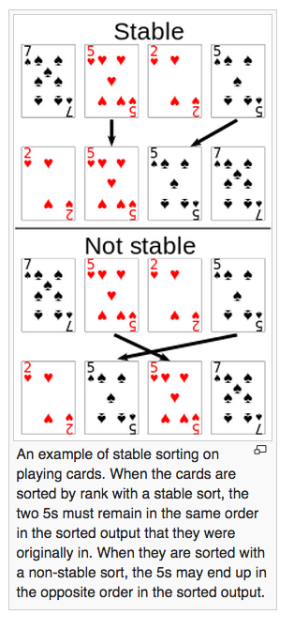

From BSIS(bubble,selection,insertion,shell) and M-HQ(merge, heap,quick) sorting algorithms, HQ are unstable.

You can also think differently – In whichever Sort, swaps(exchanges) of elements happen between distance elements (not adjustant elements), they are unstable. This is explained in Coursera video of ‘6-5 Stability (5-39).mp4’.

# Logarithm



# Big O Notation

Big O doesn’t tell you the speed in seconds. Big O notation lets you compare the number of operations.

# 

O(2^x) is in between O(n^2) and O(n!). (Cracking Coding Algorithms Book – Pg 42)



# Amortized Time

p.g. 43 of CCA book.

And

<https://stackoverflow.com/questions/200384/constant-amortized-time>

Let’s take an example of ArrayList

Normally adding an item in ArrayList takes constant time (that is, O(1)). But each time the array is full (capacity reaches), you allocate twice as much space, copy your data into the new region, and free the old space. Assuming allocates and frees run in constant time, this enlargement process takes O(n) time where n is the current size of the array.

So each time you enlarge, you take about twice as much time as the last enlarge. But you've also waited twice as long before doing it! The cost of each enlargement can thus be "spread out" among the insertions. This means that in the long term, the total time taken for adding *m* items to the array is O(m), and so the amortised time (i.e. time per insertion) is O(1).

How does the ArrayList size is grown in Java?

Default capacity is 10. When 11th one is added,

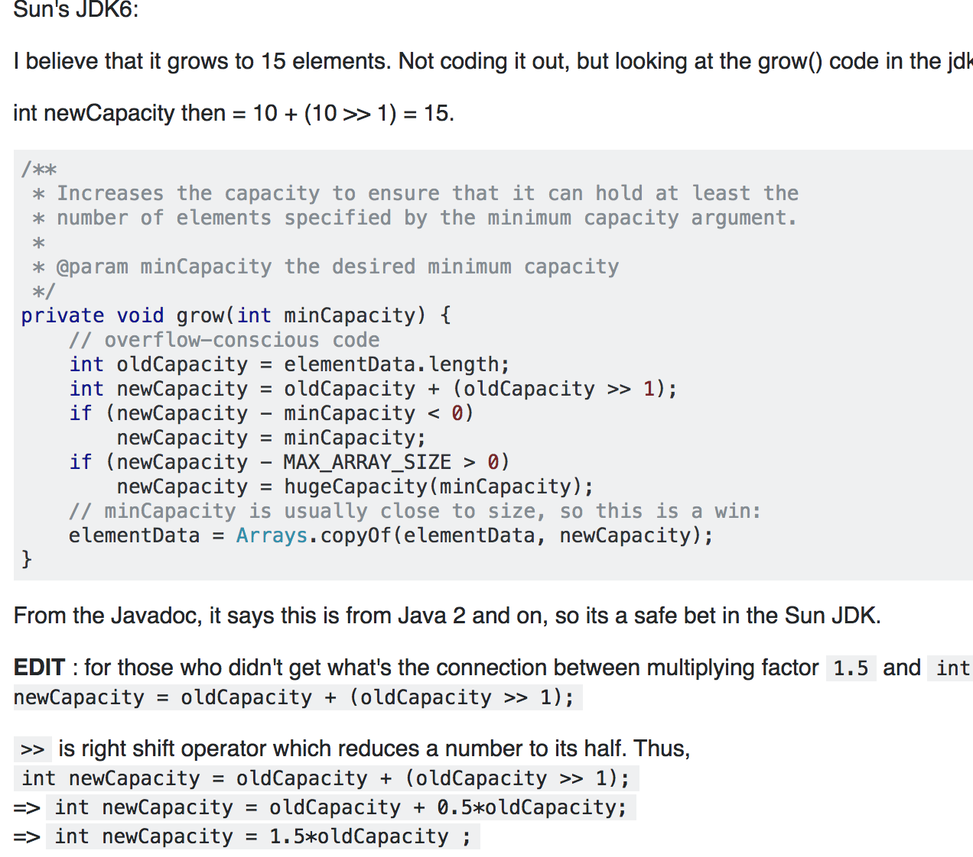

clearly, the growth factor is also 1.5

# Logarithm

<https://www.youtube.com/watch?v=ZIwmZ9m0byI>

How do you decide the base of log?



Height of this tree is 3 that is log2 14.

How do you know the base is 2?

Log2 14 = x

3.81=x

It’s a binary tree so if you use log with base 2, it gives correct height of the tree.

If it’s ternary tree, you need to use base 3 and so on to get the height of the tree.

What is Log2 8?

X = log2 8

2^x = 8 (**exponential** form of log)

x = 3

what if it is hard to find the value of x

e.g. x = log2 11

2^x = 11

it is hard to find the value of x

So, log2 11 = log 11/log 2 (default base is 10) = 3.33

**Natural log (ln)**

ln 8 is same as loge 8

x= loge 8

e^x = 8

e^x = 2^3

x = 3

**Equality**







Remember : negative number is not considered in the world of logarithm.

e.g. log -8 is undefined.

Logarithm real life example

<https://www.youtube.com/watch?v=1dUSNdZspQc>

# Binary Search

* Binary Search works only on Sorted Array.
* It doesn’t work on linked list because it has to access element by index.
* It takes O(log n).

It will create tree only one side. As it is ignoring half of array at each level, tree height is still log n with base 2.

*o  
1 comparison /\  
 o ignore this half (no comparisons)  
1 comparison /\  
 o ignore this half (no comparisons)  
1 comparison /\  
 o ignore this half (no comparisons)  
1 comparison /*

In binary search to search an element, you divide an array into two and then you keep searching on its one side.  
At each level, there is only 1 comparision happens (numberToSearch with a[middle]). It takes max O(1 log n) to search an element.

Basically, when number of comparisons halvs at each step, then time complexity is O(log n).

See Recursive Runtime and Space Complexities





# Arrays and List

# 

 If you’re out of space and need to move to a new spot in memory every time, adding a new item will be really slow.

With linked lists, your items can be anywhere in memory.



Adding an item to a linked list is easy: you stick it anywhere in memory and store the address with the previous item.

Suppose you want to read the last item in a linked list. You can’t just read it, because you don’t know what address it’s at. Instead, you have to go to item #1 to get the address foritem #2. Then you have to go to item #2 to get the address for item #3.



Lists are better if you want to insert elements into the middle.

# 



# Bubble Sort and Selection Sort

Selection sort is a stepping stone to quicksort, which I’ll cover in the next chapter. Quicksort is an important algorithm, and it will be easier to understand if you know one sorting algorithm already.

Bubble Sort:

You need to compare each element of an array with all other elements.





To find the artist with the highest play count, you have to check each item in the list. This takes O(*n*) time, as you just saw. So you have an operation that takes O(*n*) time, and you have to do that *n* times:



This takes O(*n* × *n*) time or O(*n*2) time.

Bubble Sort compares first element with other elements and if first element > other element, then exchanges(swaps) them.

**Unlike to Bubble Sort, Selection Sort does not swap the elements after every comparison.**  
It **keeps min=i**. Compares each element of array with a[min]. if a[min]>a[other index], then min=other index.  
At the end, it swaps elements of a[i] and a[other index].

But both Bubble Sort and Selection Sort takes O(n2) operations.

# Recursion

The stack of sticky notes is much simpler. When you insert an item, it gets added to the top of the list. When you read an item, you only read the topmost item, and it’s taken off the list. So your todo list has only two actions: *push* (insert) and *pop* (remove and read).



Let’s see the todo list in action.



This data structure is called a *stack*.

e.g.













Converting Recursive function to Iterative function.

Recursive function call:

fact(n) {

if(n==0) return 0;

if(n==1) return 1;

return n * fact(n-1)

}

|  |  |  |  |
| --- | --- | --- | --- |
| **step** | **Push to Stack** | **step** | **Pop from Stack** |
| 4 | If(x==1) return 1 |  |  |
| 3 | 2 * fact(1) | 5 | 2 * 1 = 2 |
| 2 | 3 * fact(2) | 6 | 3 * 2 = 6 |
| 1 | fact(3) | 7 | 6 |

Recursive function can be converted to iterative approach as follows:

fact(n) {

int total=n; --- from n * fact(n-1) sentence, total=n

while(n>1) { ---- from exit condition if(n==0) and if(n==1)

total = total * (n-1); ---- from n*fact(n-1), total = total * (n-1)

n = n-1; ----- from fact(n-1), n=n-1

}

return total;

}

Iterative approach





Recursive approach







*/* There are two ways of doing recursion  
 * - return the result from the method  
 * - pass the result parameter to the method (I think it is called memoization)*

*\*/***public class** Sum {  
 **public static void** main(String[] args) {  
 **int**[] a = {2, 3, 4};  
 System.***out***.println(*sum*(a));  
 }  
  
 **private static int** sum(**int**[] a) {  
 **if** (a == **null** || a.**length** == 0) {  
 **return** 0;  
 }  
 *//return sum(a, 0, a.length - 1);  
 // or* Result result = **new** Result();  
 *sum*(a, 0, a.**length** - 1, result);  
 **return** result.getTotal();  
 }

*// This is a typical example of reducing the problem by 1* **private static int** sum(**int**[] a, **int** start, **int** end) {  
 **if** (start == end) **return** a[start];  
 **return** a[start] + *sum*(a, ++start, end);  
 }  
  
 *// result is memoized* **private static void** sum(**int**[] a, **int** start, **int** end, Result result) {  
 **if** (start == end) {  
 result.add(a[start]);  
 **return**;  
 }  
 result.add(a[start]);  
 start++;  
 *sum*(a, start, end, result);  
 }  
  
 *// recursive method is converted into iterative method* **private static int** sumIteratively(**int**[] a) {  
 **if** (a == **null** || a.**length** == 0) {  
 **return** 0;  
 }  
 **int** start = 0; *// parameters passed to recursive method are initialized this way in iterative approach* **int** end = a.**length** - 1;  
  
 **int** total = 0; *// recursive method call is replaced by a variable 'total'.* **while** (!(start > end)) { *// exit condition of recursive method should become exit condition of while loop* total = total + a[start];  
 start++;  
 }  
  
 **return** total;  
 }  
  
 **static class** Result {  
 **int total**;  
  
 **public int** getTotal() {  
 **return total**;  
 }  
  
 **public void** setTotal(**int** total) {  
 **this**.**total** = total;  
 }  
  
 **public void** add(**int** number) {  
 **total** += number;  
 }  
 }  
}





# QuickSort

Quicksort avg takes (O(n log n) and worst O(n).

e.g. if input array is already sorted, then

array = [1,2,3,4,5]

qsort(1,2,3,4,5)

| pivot=1, compare 1 with (2,3,4,5) and create left and right arrays, left_array=[], right_array=[2,3,4,5]

qsort() + 1 + qsort(2,3,4,5)

| pivot=2, compare 2 with (3,4,5) and create left and right arrays, left_array=[], right_array=[3,4,5]

qsort() + 2 + qsort(3,4,5)

| pivot=3, compare 3 with (4,5) and create left and right arrays, left_array=[], right_array=[4,5]

qsort() + 3 + qsort(4,5)

| pivot=4, compare 4 with (5) and create left and right arrays, left_array=[], right_array=[5]

qsort() + 4 + qsort(5)

|

exit condition is met

If you see stack tree is not balanced and height of the tree is n.

At every level of tree, we compare all the elements of input array with pivot. So, it ends up with n*n comparisons.

array = [4,2,3,1,6,5]

qsort(4,2,3,1,6,5)

| pivot=4, compare 4 with (2,3,1,5) and create left and right arrays, left_array=[2,3,1], right_array=[5]

qsort(2,3,2) + qsort(6,5)

|

In this case, it will create balanced or almost balanced binary tree.

At each level of tree, there will be n comparisons, but height of the tree will be (log n). So, there will be (n log n) comparisons.

*O (n comparisons)*

*/ \  
(n/2)/ \ (n/2)  
 o o*

*(n/4) / \(n/4) (n/4) / \(n/4)  
 o o o o*

At each level of tree, there are n comparisons. So, time complexity is O(n log n)



Notice how you’re not splitting the array into two halves. Instead, one of the sub-arrays is always empty. So the call stack is really long. Now instead, suppose you always picked the middle element as the pivot. Look at the call stack now.



Whether it is worst case or best case, each level has to do O(n) operations.



when you say height of binary tress is log n, it is actually log n with base 2.

If it is ternary tree, then its height will be log n with base 3.



When you say Random Pivot, it is not a random index for Pivot. Index of Pivot is always the last one in the array. You can choose random number from array and put it at the end of array.

## Quick Sort vs Merge Sort











(IMP) If quicksort is O(n log n) on average, but merge sort is O(n log n) always, why not use merge sort? Isn’t it faster?  
Quicksort has a smaller constant than merge sort. So if they’re both O(n log n) time, quicksort is faster. And quicksort is faster in practice because it hits the average case way more often than the worst case.  
Constant time is something that is taken to do each operation. O notation doesn't take time into consideration. It takes only number of operations into consideration.

Merge sort takes time to create divide an array into two

+  
Merge sort needs auxiliary arrays. Quick sort can be done in-place.

## Quick sort vs Insertion sort

Insertion sort gives **best** performance (O(n)) for **already sorted array**. If array is reverse sorted, then it gives worst performance (O(n^2)). So, it is good for small size of array.

Quick sort gives **worst** performance for **already sorted array** (O(n^2)) unless random pivot is chosen. If random pivot is chose, it gives O(n log n)

# Hash Tables

## Binary Search vs Hash Table

Both Binary Search and Hash Table are used of faster search.

Advantage of Hash Table over Binary Search: You can search item in Hash Table in O(1), whereas Binary Search takes O(log n).

It is a white lie that it takes O(1). We will see Collision later to understand how can it take more than O(1) and it can result in O(log n).

## Requirements of Good Hashing

To avoid collisions, you need

- **A low load factor**

- **A good hash function**













## Arrays/Lists vs Hash Tables

Arrays and lists map straight to memory, but hash tables are smarter. They use a hash function to intelligently figure out where to store elements.

You can get an item from an array instantly. And hash tables use an array to store the data, so they’re equally fast.

## Usage of Hash Table

Hash Tables are widely used for

- lookups

- preventing duplicate entries

- caching

Look at the average case for hash tables. Hash tables are as fast as arrays at searching (getting a value at an index). And they’re as fast as linked lists at inserts and deletes. It’s the best of both worlds! But in the worst case, hash tables are slow at all of those. So it’s important that you don’t hit worst-case performance with hash tables. And to do that, you need to avoid collisions.



## Collisions









## Solutions to Avoid Collision

* Separate Chaining (Open Hashing)
* Open Addressing (Closed Hashing)

One of the solution to avoid collision is called 'Separate Chaining'/'Open Hashing'.

**In this method, elements with same hash value are stored in a linked list.** Slot of array points to the head of this linked list. This is good for better memory utilization, but it can take O(n) to search an element in worst case where all elements end up in the same slot of an array due to bad hash function.

­

Till Java7, HashMap uses ‘Separate Chaining’ mechanism to store elements of HashMap.

In Java8, enhancement is done to replace LinkedList by Balanced Binary Search Tree (Balanced BST). So, search takes no longer than O(log n) in worst case.



Another solution to reduce collision is 'Open Addressing'/'Closed Hashing'.

**In this method, number of array slots are significantly higher than number of elements.**

3 methods of Open Addressing are:

- Linear Probing

- Quadratic Probing

- Double Hashing

In Linear Probing,

when element has same hash value as an element in the array, then you just go to next position in the table(array) and if that is empty then put an element there.

Same while searching, if element does not exist at the index calculated from its hash value, then go to next index in the array and keep going till you find an element. If you find an empty space while searching then it means that element does not exist in the array.

In Quadratic Probing,

every time collision is found, we increment a position to insert an element in a table(array) by i^2 where i increments by 1 every time a collision is found. Compare to Linear Probing, number of collisions will be less.





In Double Hashing,

every time collision is found, we increment a position by R-(hashCode() % R). R is any prime number lower than table size.



## Performance Of Hash Table







load factor=1 is the best load factor. It means that number of elements in hash table is same as number of available slots in an array. So, there won't be any collision, if hash function is written properly.

So, load factor decides how many elements can you have in one slot of an array.

If load factor > 1, then it means that number of elements are more than number of available slots in an array of hash table.

A good rule of thumb is, resize when your load factor is greater than 0.7.

The rule of thumb is to make an array that is twice the size.

Resizing is expensive, and you don’t want to resize too often.

How to decide which element will go to which slot in array of a hash table?

hash(key) % M, where M is total number of slots available in array.

Many times it's ok to have 5 elements in one slot of an array. So, M(total number of slots in array) can be N/5.

String is the most complicated one to calculate the hash value.

Someone found out the best way to find out hash value of a string is using a prime number 31

hash("abcd")=97*31^3 + 98*31^2 + 99*31^1 + 100*31^0



# Graph (BFS, DFS and Dikjstra’s Algorithm)

Best to read it from book

and

MyJavaProject/algorithms/graphmanipulation/BfsDfsFromGrokkingAlgorithmBook.java and DijkstraAlgorithmForPositivelyWeightedGraphGrokkingAlgorithmBook.java

# Greedy Algorithm



NP-complete problem means a problem that takes Nondeterministic Polynomial Time to complete (generally n! – n factorial time).

There are two ways to solve this kind of problem – Greedy Algorithm, Dynamic Programming(0/1 Knapsack Problem).

Greedy Algorithm will work in any problem and its easy, but there are certain conditions for Dynamic Programming to work. You will see those conditions in next chapter. In this chapter, we will try to understand Greedy Algorithm.

Whenever you see a problem like Travel Person or Set Covering problem, remember it’s NP-Complete problem. So, only rescue for you is to use Greedy Algorithm.

With these problems, you need to think n! combinations before reaching to right ideal solution. Greedy Algorithm doesn’t do that. It just starts with most optimal choice without thinking of end result. At the end, it may or may not reach to most optimal solution, but it will be close to optimal.

A greedy algorithm is an algorithmic paradigm that follows **the problem solving heuristic of making the locally optimal choice at each stage with the hope of finding a global optimum**. In many problems, a greedy strategy does not in general produce an optimal solution, **but nonetheless a greedy heuristic may yield locally optimal solutions that approximate a global optimal solution in a reasonable time.**

**Dijkstra's Algorithm:**

You can call this algorithm **PARTIALLY GREEDY** Algorithm also because it starts with Lowest cost edge (Locally Optimal Solution) without thinking of entire graph and at the end it reaches to final solution (Globally Optimal Solution).

But unlike to Dijkstra's Algorithm, Greedy Algorithm may not find optimal solution at the end.

Dijkstra's Algorithm always find optimal fastest path at the end because it doesn't visit already visited vertices.

## Travel salesperson problem















Greedy Algorithm is an answer for this kind of problems.



## Set-Covering Problem

























IMPORTANT:

Dijkstra’s algorithm of Graph is a Partial Greedy Algorithm. Without thinking of all combinations to find the fastest route to reach from A to Z vertices, it starts with the lowest cost route that can it to A to B and eventually to Z.

Why it is Partial Greedy?

Greedy Algorithm doesn’t guarantee that it will find the optimal solution at the end. It will be close to optimal. It just focuses on next optimal step, whereas Dijkstra’s algorithm gives optimal solution always by not visiting already visited vertices.

# Dynamic Programming

Greedy Algorithm is easy, quick and gives you close to optimal result for n! operations problem.

If you want optimal result for n! operations problem, you need to use Dynamic Programming. It is hard, but gives you the optimal solution.

Dynamic Programming doesn’t work all the time. You can’t replace Greedy Algorithm by Dynamic Programming all the time. There are some pre-requisies for Dynamic Programming.

Dynamic Programming is called a solution for ‘0/1 Knacksap Problem’.

What is Knacksap problem?

Meaning of Knacksap is a bagpack. Assume, that you are a thief and you want to steal the items from a store. There are items with different weights and values. Your backpack can hold only certain amount of total weight. You want steal the items that are most valuable.

In this problem, you have been given

* the total weight that your knacksap can hold
* and how much each item weighs and valued

These are the pre-requisites for Dynamic Programming.

**For real solution follow a video ‘0_1 Knapsack problem using dynamic approach.mp4’ at** [**https://www.youtube.com/watch?v=IL5zz02ojm4**](https://www.youtube.com/watch?v=IL5zz02ojm4)



You have a backpack (knapsack) that hold max 7 pounds of weight. You want to steal some items of different weights and values in such a way tha they can fit in your knapsack and you can steal highest valued items.

As per the picture, it is satisfying all the requirements to use Dynamic Programming. You have items having exact weight and value. You have been given total weight that your knapsack can hold.

This picture shows that you are trying to solve the problems for smaller knapsacks that can hold 1,2,3… pounds of weight and eventually in the last knapsap (row 7, col 7), you will reach to the solution with what items you can put in your knapsack that can give you the advantage of highest values.

Follow the video to learn step by step instructions to fill up the cells in above matrix.

**Following is an example of real problem, but do not follow the formulas the way optimal solution is calculated. For real solution follow above mentioned video.**





















































# KNN (K-Nearest Neighbours) Algorithm

K-nearest neighbours (KNN) algorithm helps for

* classification
* recommendation
* regression

for the item.

## Classification:

you have 10 items. out of 10, 5 are oranges, 4 are grapes. But by seeing the 1 that is remained you are not able to figure out whether it is an orange or a grape. You plot all the fruits as per their shape,size etc attributes on the graph. Find the nearest k number of neighbours to that fruit. If more oranges are closer then it's an orange, otherwise it's a grape.

K can be 1,2,3,... any number of neighbours that you choose that you want the unidentified item to compare with.





## Recommendation

You have 10 users using netflix. You know some attributes of each user like age, location, interested movie types etc. A new user is joining the netflix. How netflix can recommend some movies to watch to that new user? Based on available users data, you can plot all the users on graph and find nearest k neighbours for that new user and recommend the movies to that new new user based on their k-neighbours watched movies.

## Regression

You have historical data and based on that you want to predict the future.

e.g. you have data about your company. In what year how many employees were hired and what was the company's revenue. You have this year's company's revenue. You want to predict how many employees will be hired this year.

You can plot all the information on graph and predict the number of employees that company will hire this year.

## Machine Learning

KNN is a really useful algorithm, and it’s your introduction to the magical world of machine learning! Machine learning is all about making your computer more intelligent. You already saw one example of machine learning: building a recommendations system.

OCR system is one of the example of Machine learning. It can recognize the letter and number (images etc) by comparing it with data that is available to the system from the past. You can read about OCR from the book.

In Machine Learning, you need to first train the system with few data and then system can compare new data with old data and predict the type of new data. If you think that this is wrong prediction, feed that feedback back to system and system will learn from it do the better prediction next time.

# Binary Search vs Binary Search Tree

Binary Search needs sorted array. Whenever a new element needs to be added in an array, array needs to be sorted. This is not good.

BST works BEST on unordered array with O(log n). It works worse on ordered array with O(n) search time.

BST is a symmetric tree. Means left nodes of any nodes are always lesser and right nodes are always bigger.

BST takes O(log n) for insert/delete. It takes avg O(log n) and worse O(n) for search. Worst case is when BST is created from sorted array. BST will have all elements on one side of the tree only. That's why height of the tree will be n because it won't be balanced.

Unbalanced Tree:



Comparing BST to Binary Search:

For Binary Search, you need sorted array, so Inserting and deleting in array to keep it sorted may take O(n). Search takes same as Binary Search.

So BST has an advantage over Binary Search for insert/delete/search when array is unordered.



# Special Trees

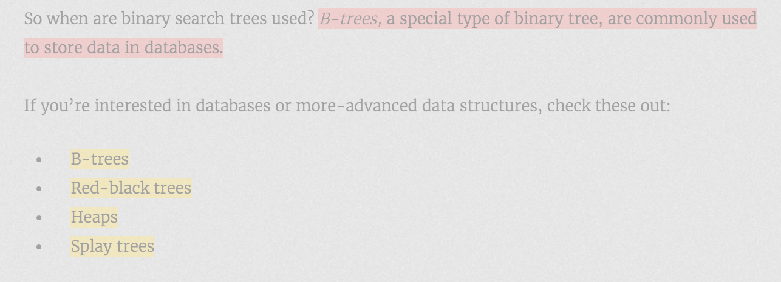

# Inverted Index

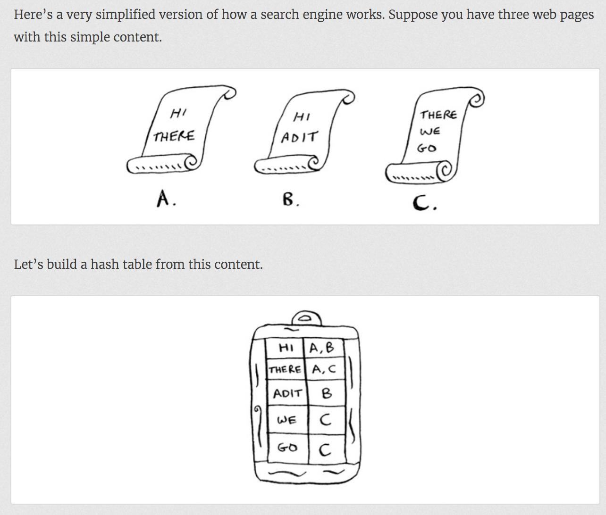

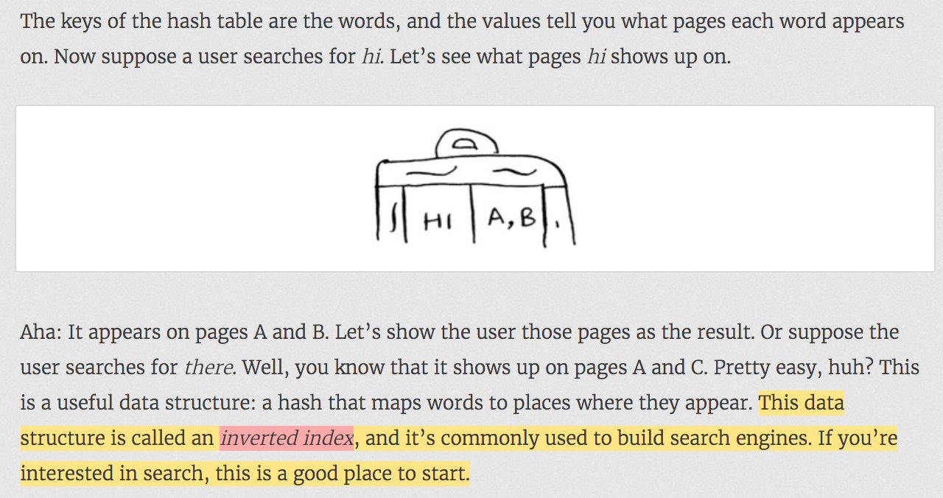

Elastic Search usea Inverted Index.

# The Fourier Transform

<https://www.youtube.com/watch?v=olV8rSKn2a4>

Fourier transform works on complex mathematical equation. it is useful to extract the components of the thing that is made of. e.g. it can extract properties from DNA and based on the amount of certain components in DNA, they can predict many things.

Similar concept works on song having different frequencies.

# Parallel Algorithm

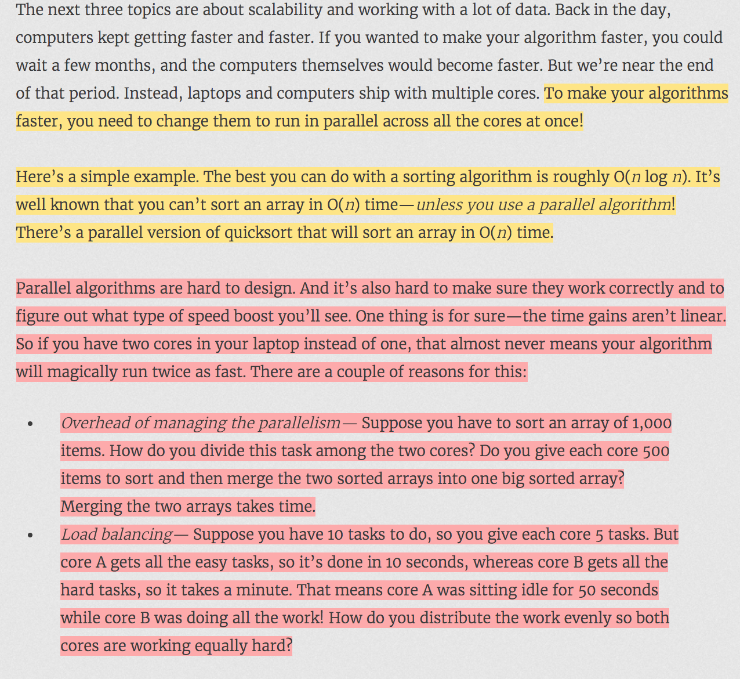

See QuickSort using Parallel Processing in Sorting.java

# MapReduce

The MapReduce algorithm is a popular distributed algorithm.

Suppose you have a table with billions or trillions of rows, and you want to run a complicated SQL query on it. You can’t run it on MySQL, because it struggles after a few billion rows. Use MapReduce through Hadoop!

# Bloom Filter and HyperLogLog

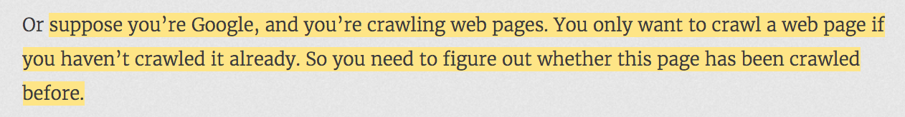

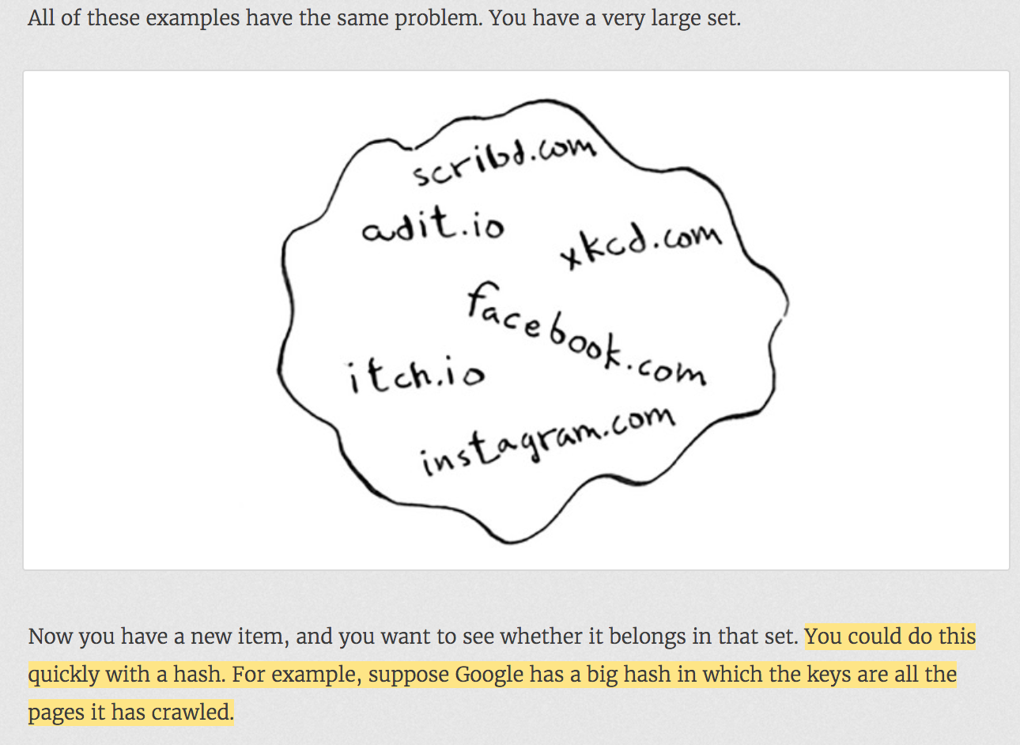

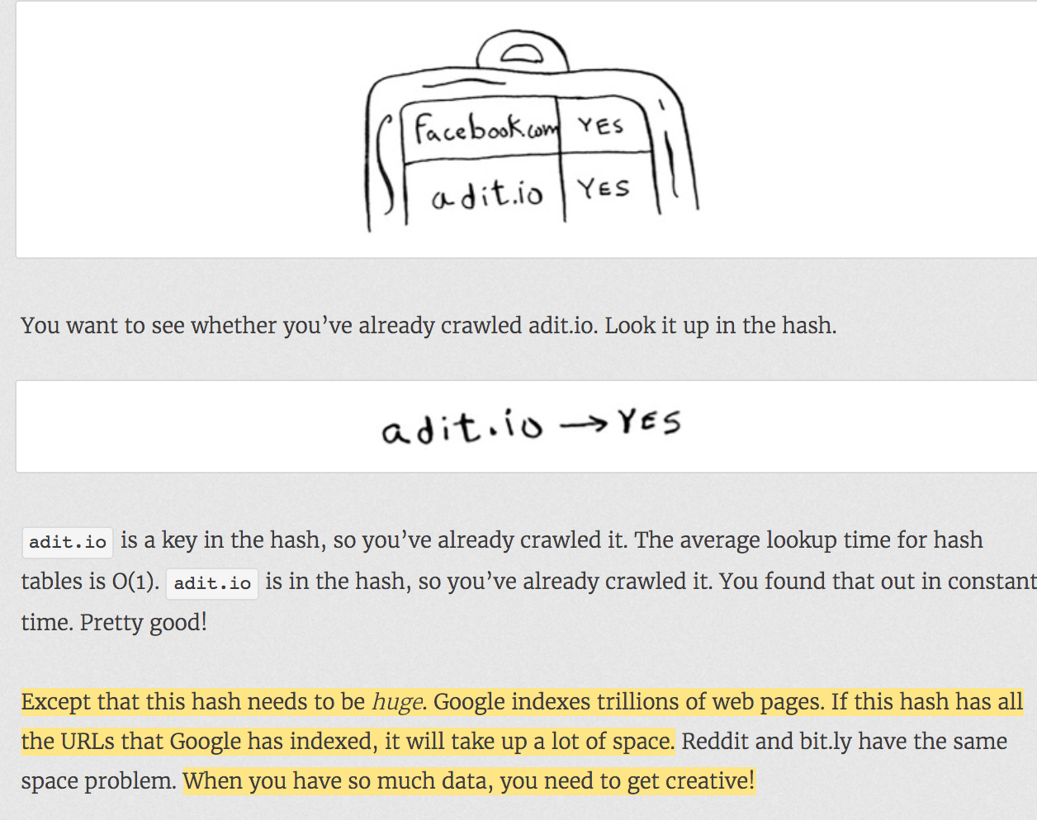

Bloom Filters

<https://www.youtube.com/watch?v=x2sLjRK56YU>

Where hashing becomes more expensive and sometimes wrong result is acceptable, then you can use Bloom Filter for better use of memory.

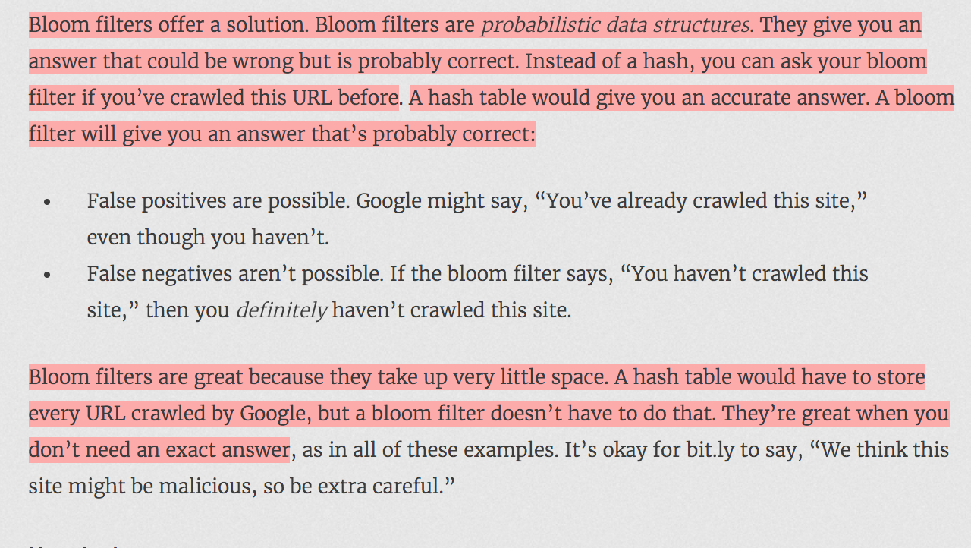

HyperLogLog

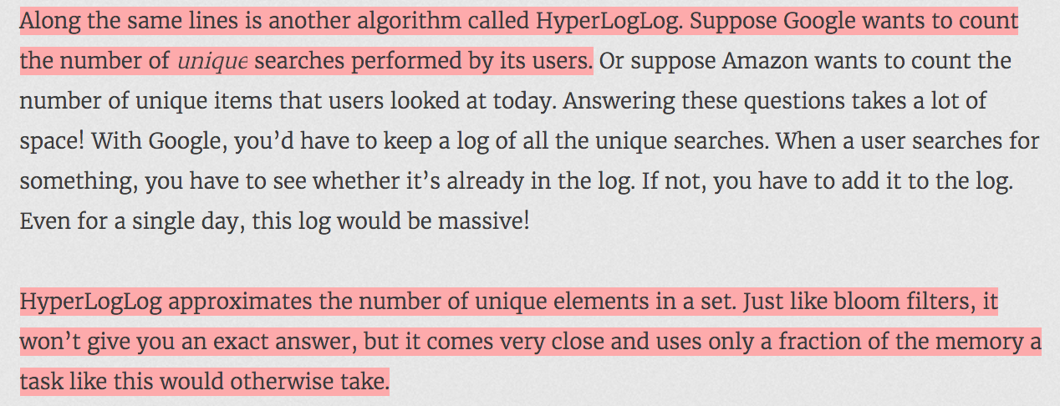

# The SHA Algorithms

## Comparing Files

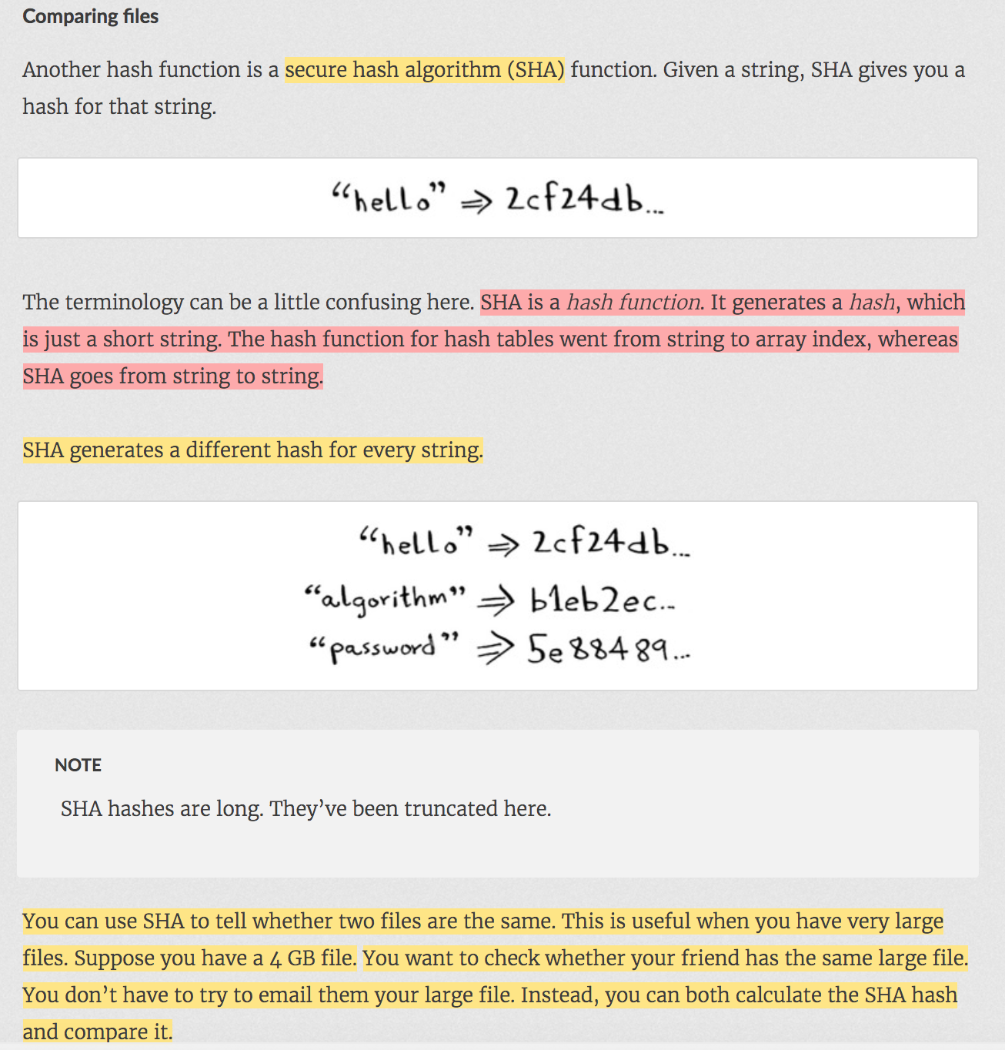

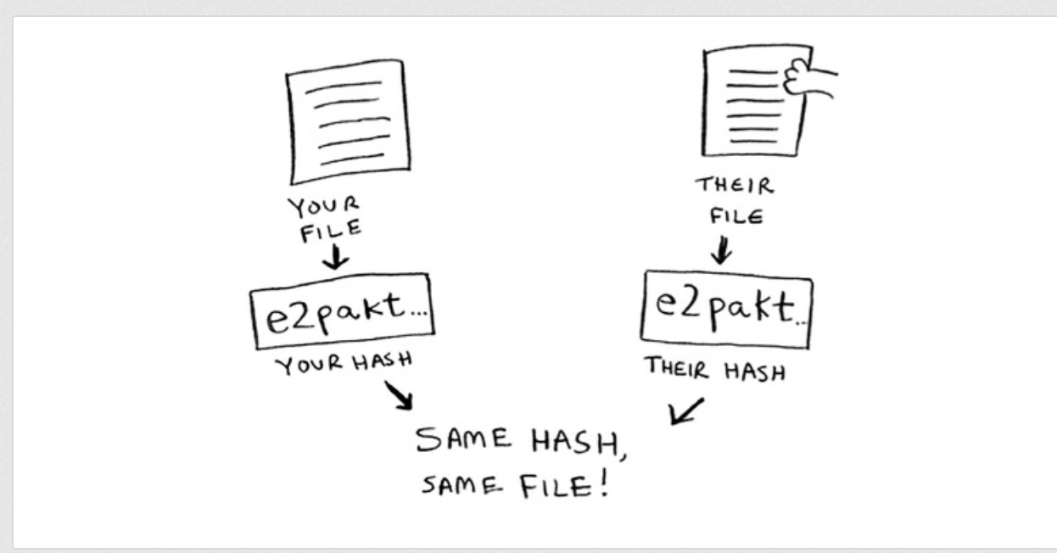

## Checking Passwords

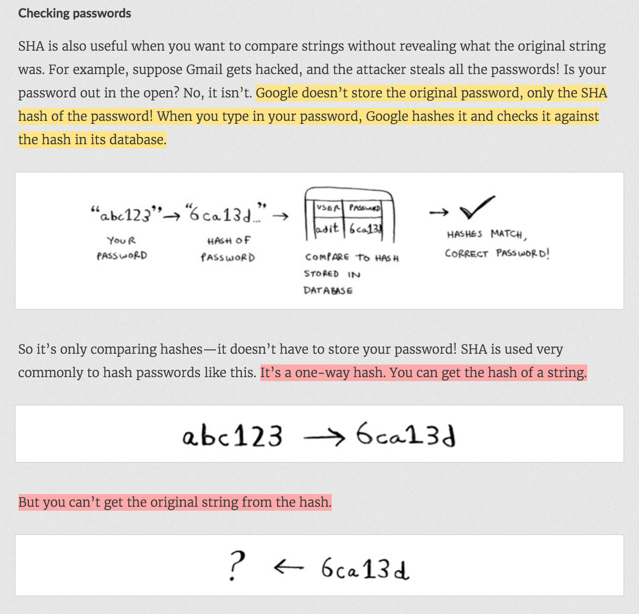

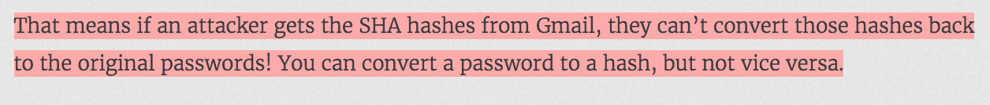

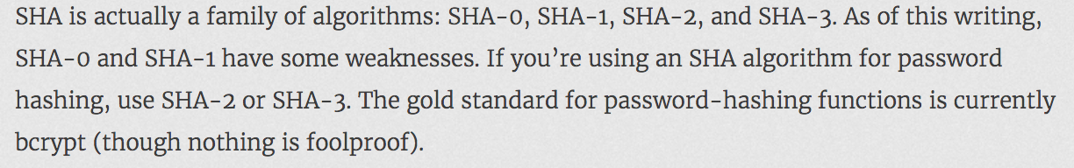

## Locality-sensitive hasing

SHA is locality insensitive whereas SimHash is locality sensitive.

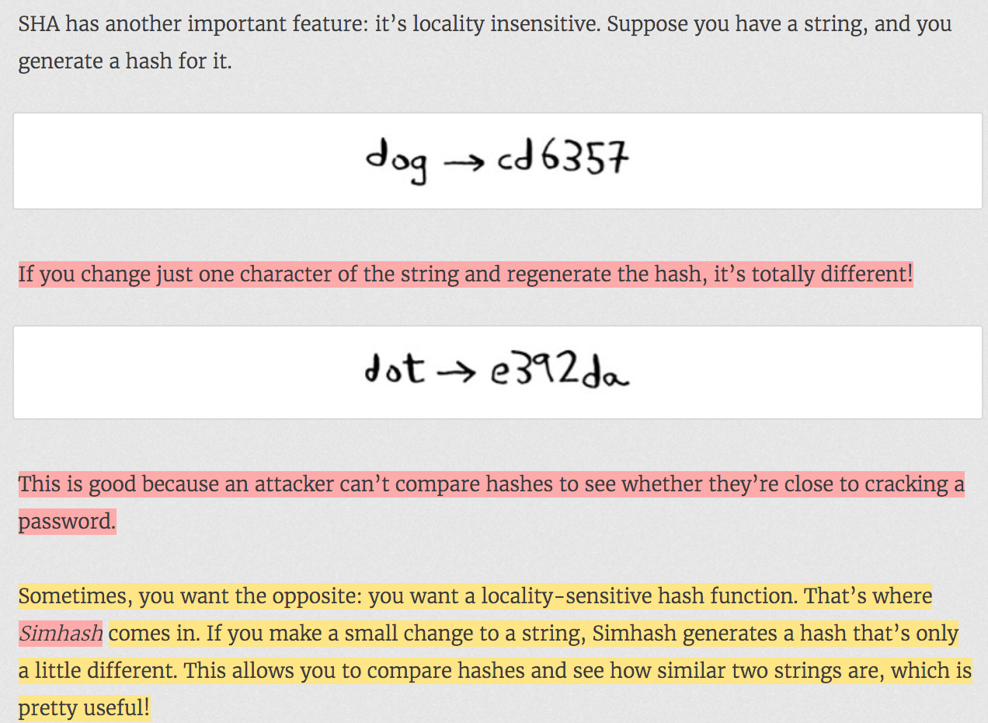

Simhash is useful when you want to check for similar items.

## Diffie-Hellman key exchange

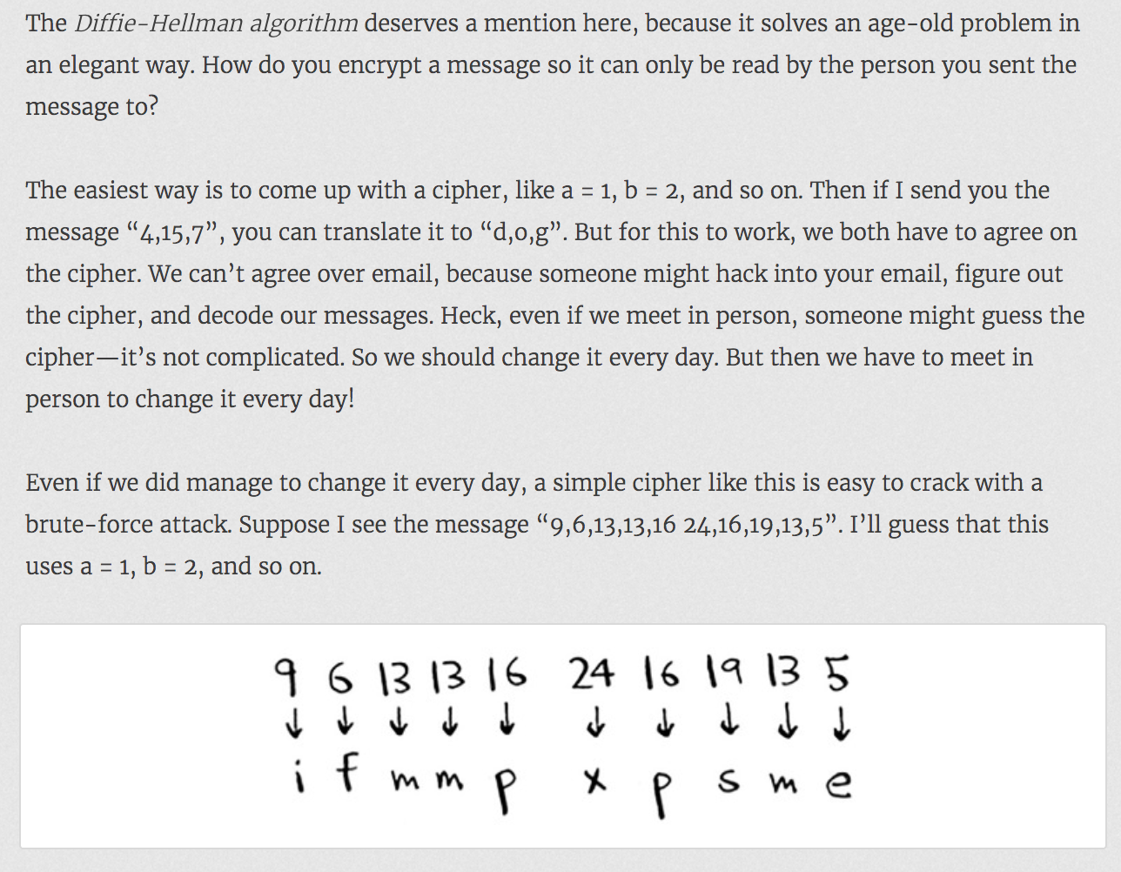

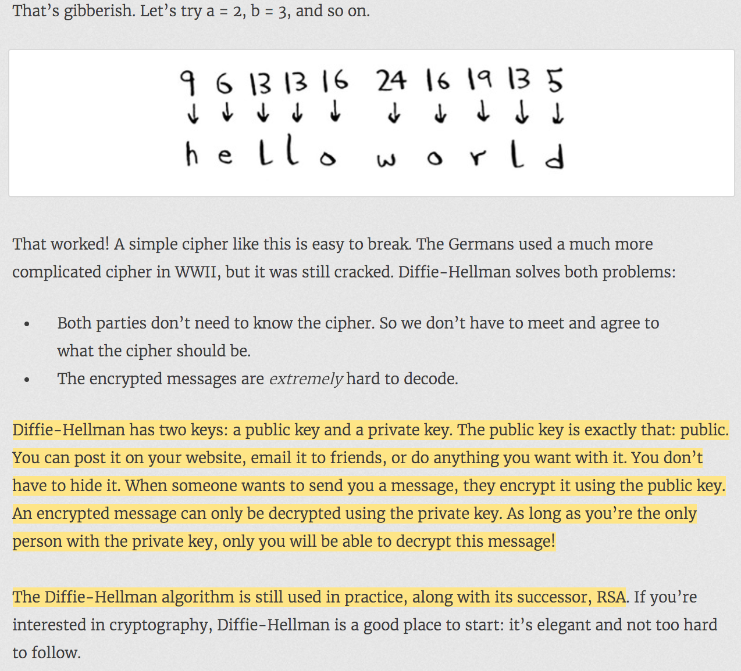

# Linear programming

<https://www.youtube.com/watch?v=M4K6HYLHREQ>

Under some constraint, you need to maximize something (e.g. profit)

As mentioned in above youtube video, constraint is number of available hours for farming. In that constraint, you need to maximize the profit by putting some corns and some oats plants giving different amount of profits.

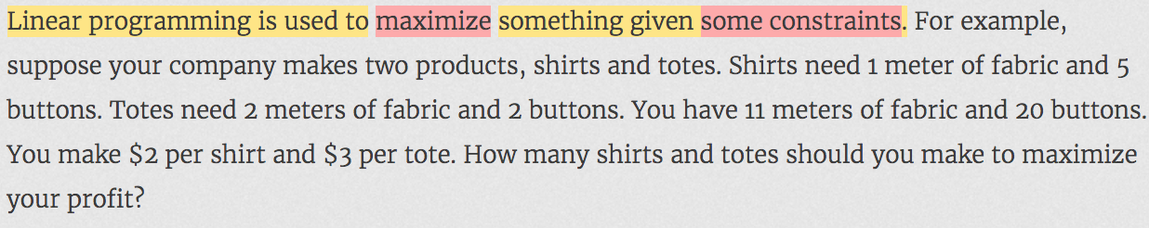

# String

p.g. 89 of CCA book

String joinWords(String[] wods) {

String sentence = “”;

for(String w : words) {

sentence = sentence + w;

}

return sentence;

}

String concatenation takes O(xn^2) where as StringBuilder/StringBuffer’s append takes O(xn).

You can think of String concatenation as **System.arrayCopy** operation for every concatenation.

You can think of StringBuilder as Resizable array (like **ArrayList**) where resizing an array takes Amortized time.

On each concatenation, a new copy of he string is creted and two strings are copied over character by character. The first iteration requires us to copy x characters. The second interation requires copying 2x characters. The third iteration requires 3x, and so on. The toral time therefore is O(x+2x+3x+…..+nx) = x(1+2+3+…+n)= xn(n+1)/2 = O(xn^2)=O(n^2)

String joinWords(String[] wods) {

String sentence = new StringBuilder();

for(String w : words) {

sentence.append(w);

}

return sentence.toString();

}

Creating a StringBuilder is just like creating an ArrayList. It creates an array of some initial size. When you do append operation, it copies a string character by character. When it realizes that array is almost going to be full, it creates an array of a lot bigger size and copies the previous array to new array. But this operation happens very few times. So, if distribute the cost of this operation on number of inserts, cost is Amortized to O(1). So, cost of resizing is negligible.